1. Write the SELECT statement to extract the IDs of employees who are more than 30 years of age.
SELECT emp_id
FROM employee_data
WHERE age > 30;
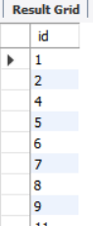

- Write the SELECT statement to extract the first and last names of all web designers.
SELECT f_name, l_name
FROM employee_data
WHERE title = 'Web Designer';
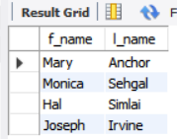

- What will the following SELECT statement display?
SELECT * FROM employee_data WHERE salary <= 100000;
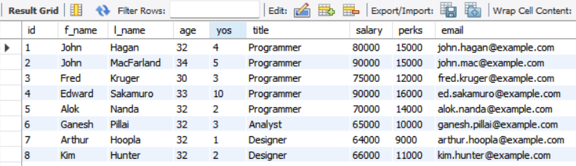

- How will you display the salaries and perks for employees who have more than $16,000 as perks?
SELECT salary, perks
FROM employee_data
WHERE perks > 16000;
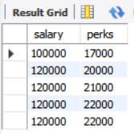

- List all employee names (last name followed by first name) who hold the title of Marketing Executive.
SELECT l_name, f_name
FROM employee_data
WHERE title = 'Marketing Executive';
